APPROACHING ABSTRACT ART
Central Focus | This unit will focus on creating abstract art through different artistic approaches and using a variety of materials.
Grade Level | 5th
Class Size | 25
Time | 50 minutes
Class Demographics | 60% white, 20% Black, 12% Hispanic, 5% Asian, 3% Other; 57% female, 43% male; public, urban school; 1% disabled

National Visual Arts Standards Addressed
- VA:Cr1.2.5a: Identify and demonstrate diverse methods of artistic investigation to choose an approach for beginning a work of art.
- VA:Cr2.1.5a: Experiment and develop skills in multiple art-making techniques and approaches through practice.
- VA:Cr3.1.5a: Create artist statements using art vocabulary to describe personal choices in artmaking.
- VA:Re.7.1.5a: Compare one's own interpretation of a work of art with the interpretation of others.
- VA:Re9.1.5a: Recognize differences in criteria used to evaluate works of art depending on styles, genres, and media as well as historical and cultural contexts.
- VA:Cn10.1.5a: Apply formal and conceptual vocabularies of art and design to view surroundings in new ways through artmaking.

UNIT OVERVIEW
In this unit the students will create multiple works of abstract art, using different approaches and materials. Such as sound, geometry, and observation; and watercolor, markers, and colored pencils. They will gain a better understanding of what abstraction is and how artists achieve it.

Forms | 2D |  | 3D |  | 4D
Frames | Cultural | Subjective |  | Structural |  | Postmodern
Conceptual  Framework | Artwork | Artist |  | Audience |  | World

Interdisciplinary Connections
- English
- Math (geometry)
- History

UNIT LEARNING OBJECTIVES

As a result of this lesson, students will be able to:
- Students will incorporate historical approaches of abstraction in their work (VA:Cr1.2.5a) (VA:Cr2.1.5a)
- Students will be able to create abstract art (VA:Cn10.1.5a) (VA:Cr2.1.5a)
- Students will be able to explain their creation process to their peers and how it falls into the approaches of abstraction we have discussed (VA:Cr3.1.5a) (VA:Re.7.1.5a) (VA:Re9.1.5a)

TEACHER MATERIALS
- Computer  - Projector | - Artist presentations  - Artist handouts  - Tape | - Teacher examples  - Templates for abstract grid  - Templates for artist statement

STUDENT MATERIALS
- Water/water cups  - Watercolor paint  - Paint brushes  - Watercolor paper  - Sketchbook  - A color wheel (made in a previous unit) | - Markers  - Pencil  - Ruler  - 8”x8” paper with 4x4 grid  - Scissors  - Tape | - 2” squares for shape template  - iPads  - Black and white/gray-scale-colored pencils  - Drawing paper  - Artist statement sheet

ARTISTS IN CONTEXT
Key Artists | Wassily Kandinsky, Odili Donald Odita, Piet Mondrian, Georgia O’Keefe, Albert Renger-Patzsch
Key Artworks | Wassily Kandinsky, Composition VII, 1913  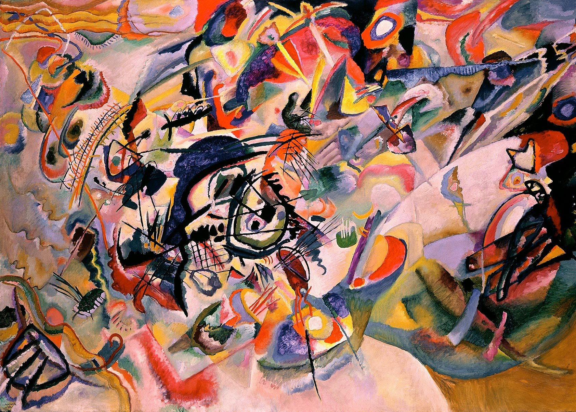  Odili Donald Odita, Phantom’s Shadow, 2018  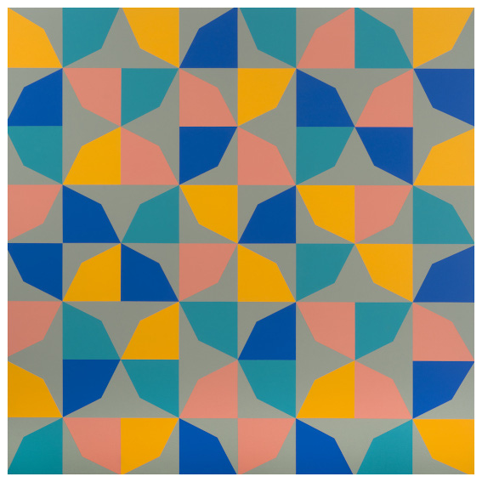  Georgia O’Keeffe, Flower Abstraction, 1924  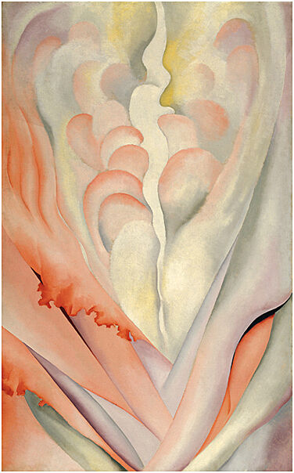  Albert Renger-Patzsch, Fungi Lepiota procera, ca 1930  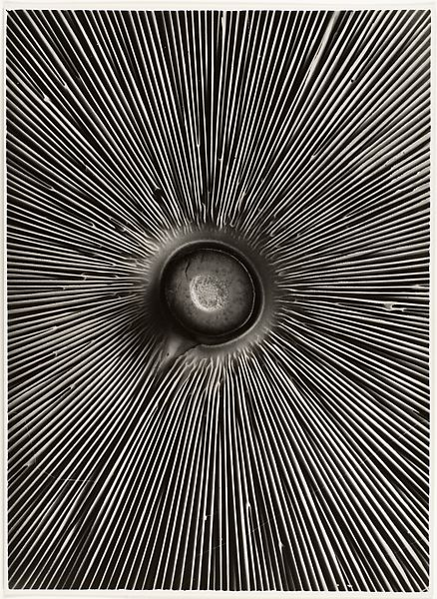
Key Critical Questions | - What do you think about when you hear the term abstract art?  - How are these methods of making abstract art similar and different?  - What type of abstraction most closely fits you first idea of abstraction?  - How have your ideas of abstraction changed?  - Do you notice a pattern in Odili Donald Odita’s work?  - What do you imagine the song Kandinsky listened to while making this work sounded like? Why?

VOCABULARY AND LANGUAGE ACQUISITION
Vocabulary | Abstract art: art that does not attempt to represent external reality, but seeks to achieve its effect using shapes, forms, colors, and textures  Rotation: turns the figure around a point  Reflection: flips the figure over a line to create a mirror image  Translation: slides the figure to a different location  Pattern: a repeated decorative design  Contrasting colors: the complementary colors, those opposite on the color wheel (blue and orange; red and green; yellow and purple). One color next to another causes it to stand out/pop more.  Bold/vibrant colors: very bright and strong
Language Functions | analyze, compare/contrast, critique, describe
Language Demands | Syntax | Discourse
Language Tasks and Activities | - Multiple group discussions about abstraction, artists, and their art  - They will write an artist statement  - Read classmates’ artists statements
Language Supports | - Power Points during short teacher lecture on artists  - Artist handouts with relevant vocab

SPECIAL PRE-INSTRUCTION PREPARATIONS
- The teacher will have to create 3 artist presentations and handouts, prepare grid templates, ensure every student will have a device for taking photos, and prep the classroom for a gallery show for students.

ACCOMODATIONS FOR SPECIFIC DIVERSE LEARNERS
Adaptations and Accommodations
- For students who will need it the teacher will have printed form of the artist presentations with speaker notes included.
- Around the front of chairs there will be bouncy bands, to help anxious and active students stay on task
- Provide precise step-by-step directions
- Teacher examples will stay on display throughout unit for reference
- Daily and weekly to-do list on the board
Enrichment and Extensions
- Combine elements from at least 2 abstraction approaches to create a cohesive image
Activity for Early Finishers
- Using purely geometric shapes create an image of your home or a self-portrait.

OBJECTIVE-DRIVEN ASSESSMENTS
- Rubric assessing students’ finished project effort and conceptual development (Objective 1)
- Rubric assessing students’ artist statement for understanding of application of abstract concepts and personal understanding (Objective 3)
- Rubric assessing students’ participation in class and group discussion about abstract art (Objective 2)
- Two works using the sound approach (2) (1)
- One work using the geometry approach (2) (1)
- One work using the observation approach (2) (1)
- One finished work demonstrating at least one of the three approaches (2) (1)
- An artist statement for their finished work (3)
- Class/group discussions (3)

REFERENCES
Encyclopædia Britannica, inc. (n.d.). Abstract art. Encyclopædia Britannica. Retrieved November 15, 2021, from https://www.britannica.com/art/abstract-art.
Encyclopædia Britannica, inc. (n.d.). Wassily Kandinsky. Encyclopædia Britannica. Retrieved November 15, 2021, from https://www.britannica.com/biography/Wassily-Kandinsky.
Georgia o'keeffe: Abstraction. Georgia O'Keeffe: Abstraction | Whitney Museum of American Art. (n.d.). Retrieved November 14, 2021, from https://whitney.org/exhibitions/georgia-o-keeffe.
IdeelArt: The Online Gallerist. IdeelArt.com. (2020). Retrieved November 14, 2021, from https://www.ideelart.com/magazine/african-american-abstract-artists.
IXL: Reflection, rotation, and translation: 5th grade math. IXL Learning. (n.d.). Retrieved December 9, 2021, from https://www.ixl.com/math/grade-5/reflection-rotation-and-translation#:~:text=A%20reflection%20flips%20the%20figure,figure%20to%20a%20different%20location.
Odili Donald Odita " artists " Jack shainman gallery. " Artists " Jack Shainman Gallery. (n.d.). Retrieved November 15, 2021, from https://jackshainman.com/artists/odili_donald_odita.
Rotation. Math is Fun. (n.d.). Retrieved November 15, 2021, from https://www.mathsisfun.com/geometry/rotation.html.
Will, M. (2021, May 3). Wiggle while you work: Study finds bouncy bands keep students on Task. Education Week. Retrieved November 14, 2021, from https://www.edweek.org/teaching-learning/wiggle-while-you-work-study-finds-bouncy-bands-keep-students-on-task/2017/08.

* Developed and written by Grace Forberg, Art Education, Illinois State University, 2021 *

INSTRUCTIONAL STRATEGIES AND LEARNING TASKS DAY / LESSON 1
Launch | Instruction Methods
- What do you think of when you hear the phrase abstract art?  - Don’t say the answer out loud but instead draw it in your sketch book.  - Students will use their own writing utensil and their class sketch book  - Share your drawings with the class. | - For 5 minutes the students will work on their drawings. (Independent student work)  - Group discussion for 5 minutes
Instruction | Instruction Methods
- The teacher will lead a discussion about abstract art and the different approaches used to make abstraction.  - What approach did you use when coming up with your quick abstract work?  - Do you believe some techniques were more effective?  - How do you feel towards abstract art?  - The teacher will present on Wassily Kandinsky using a power point with examples of his work. (the sound approach)  - Kandinsky is considered by many to be the first abstract artist (Hilma af Klint is also considered the first but there is a debate about this because her was not seen by the public until 2018 so she did not have the same influence as Kandinsky) (For the purpose of this unit we will be focusing on Kandinsky)  - A Russian from the early 20th century  - In his paintings he focused on color, line, and shape  - He would listen to music to inspire the different forms and colors he made in the moment  - His paintings were intended to produce feelings of emotions and understanding about the music by just looking at the painting  - Do you think he accomplished what he set out to do?  - Can you get an idea of what the song was like by looking at the painting?  - The teacher will play 2 songs each around 5 minutes while the students create a piece for each song.  - The students will use the watercolors to accomplish this task  - Supplies will be already set up in the center of each table  - What differences do you notice between your two works?  - How did you approach the concept of abstraction through music differently than Kandinsky? | - Direct instruction/ group discussion for 15 minutes  - Independent student work for 10  - Group discussion 5 minutes
Closure | Instruction Methods
- The students will clean up their supplies.  - The teacher will ask to reflect on their ideas/works on abstraction from the beginning of class and to share if they wish. | - Independent student work for 5 minutes  - Group discussion/ self-reflection for 5 minutes

INSTRUCTIONAL STRATEGIES AND LEARNING TASKS DAY / LESSON 2
Launch | Instruction Methods
- Take out your sketch book and fill a page with shapes | - Independent student work for 5 minutes
Instruction | Instruction Methods
- The teacher will introduce the students to Odili Donald Odita through a presentation (geometry approach)  - Odita is a Nigerian American abstract artist  - He uses vibrant colors and geometric shapes to create his paintings  - Here he uses a grid and the mathematic ideas you will have learned about reflection, rotation, and translation (we will review) to create an interesting pattern  - What does his work remind you of?  - Have you ever though that you could combine math and art?  - How do the bold and contrasting colors add to the composition?  - The teacher will hand out an 8”x8” paper with 4x4 grid, this will be what their composition is made on  - The teacher will also hand out two 2” squares per student for them to create their geometric shape on  - Students will create an original shape on their 2” square and then cut it out  - The cut-out shape will be traced in each square of the grid  - Their shape will be reflected, rotated, or translated across their grid  - Students will color using markers or colored pencils to finish the work  - Clean up | - Direct instruction/ group discussion for 8 minutes  - Independent student work for 32 minutes
Closure | Instruction Methods
- How are the 2 approaches to abstraction we learned about different from each other? | - Group discussion for 5 minutes

INSTRUCTIONAL STRATEGIES AND LEARNING TASKS DAY / LESSON 3
Launch | Instruction Methods
- Draw one item from your book bag in your sketchbook, try to pay attention to the shapes that make up the item | - Independent student work for 5 minutes
Instruction | Instruction Methods
- Teacher will present on Georgia O’Keefe and Albert Renger-Patzsch (the observation approach)  - O’Keefe works with painting and Renger-Patzsch with photography  - Both use objects from our world to create abstract images, by focusing on forms and the shapes that make them  - Renger-Patzsch works in black and white this helps emphasize form  - Do these artists change your idea of what abstract art can be?  - How is this method different from the other ones we’ve discussed?  - With your iPads take up close pictures of objects inside the classroom or right outside in the hallway.  - Put a black and white filter on the photo you choose to use as a reference  - Now you can focus on the forms and not what the actual object is  - Spend the rest of class drawing your image using the black and white/ gray scale colored pencils  - Clean up | - Direct instruction/ group discussion for 10 minutes  - Independent student work for 32 minutes (5-7) for pictures
Closure | Instruction Methods
- Show your table your phots and the work you made  - With your table discuss what style of abstraction has been your favorite | - Independent group discussion for 3 minutes

INSTRUCTIONAL STRATEGIES AND LEARNING TASKS DAY / LESSON 4
Launch | Instruction Methods
- Choose either the sound approach (Wassily Kandinsky), the geometry approach (Odili Donald Odita), or the observation approach (O’Keefe and Renger-Patzsch) and make a quick doodle inspired by it  - The teacher will play a song for those who choose sound | - Independent student work for 5 minutes
Instruction | Instruction Methods
- Now choose a style of abstraction, it doesn’t have to be the same one as your sketch, and make a final piece of abstract art  - In the back of the class their will be a table set up with the supplies necessary for all the approaches. The students will go up by table to grab supplies.  - Students doing the sound approach will have to go to the teacher to help set them up with a song and headphones.  - Students will work on piece for most of the class time  - The students can talk quietly with their table  - They can discuss ideas for their project with each other  - Clean up with 5 minutes left | - Independent student work for 40 minutes
Closure | Instruction Methods
- With your table talk about the different types of abstraction you chose to work with  - What approach did you choose? Why?  - In what ways is your art an example of that approach?  - What do you like about your classmates’ art? | - Independent group discussion for 5 minutes

INSTRUCTION
AL STRATEGIES AND LEARNING TASKS DAY / LESSON 5
Launch | Instruction Methods
- Choose an approach to abstraction you did not use on your final project and make a quick doodle inspired by it. | - Independent student work for 5 minutes
Instruction | Instruction Methods
- For our final day of the unit, we will have a gallery show  - To accompany your art works you will write 2-3 sentences about your work  - What style of abstraction did you choose? Why?  - If Kandinsky, what song did you listen to?  - What do you like about your work?  - Did you use rotation, reflection, translation, or any combination of the three?  - Next, we will hang your work statement next to your works I have already hung around the classroom  - Now we will walk around the classroom to look at your classmate’s art and read their statements | - Independent student work for 15 minutes  - Independent group reflection for 25 minutes
Closure | Instruction Methods
- What approaches to abstraction did your classmates use?  - What are your thoughts on abstract art? | - Group discussion for 5 minutes

